Moving your still pictures to iMovie to create a video

For older versions of iMovie: (for newer versions, skip down to blue text)
First, before you start importing, open iMovie and go to File>Project Properties. This will open this dialog box:
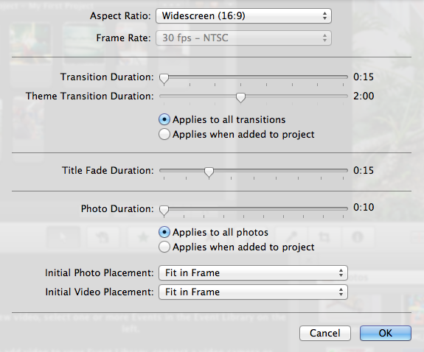

Change the information at the bottom of the box (photo duration to minimum, check on “applies to all photos” and choose the bottom two choices to “fit in frame”. Then check OK. This will ensure that all your photos will be imported as short as possible and in their entirety. If you do not do this first, iMovie will import your photos with an effect called “Ken Burns” – which moves the photo around. After you’ve changed the preference, import all your pictures. iMovie brings your pictures in from iPhoto – so you have to download all your pictures to iPhoto first. To do that, plug in your camera and import your images.

If you are importing them through iPhoto, click on the camera in the right hand side of the center. This will bring up your photos.
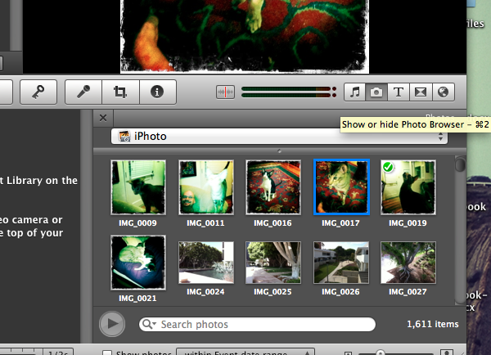

Click on the first picture, then hold down shift and select the rest of the photos, then once they are all highlighted, drag them up to the project space. Double click on one of your photos, then change the duration to .10 (minimum size available), and and be sure ‘applies to all stills’ is selected. This will make sure your photos are as short as they can be.

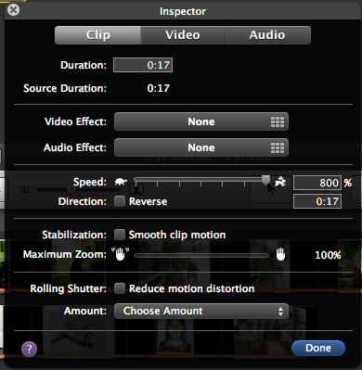
Once you get them all lined up, you can export your movie. Go to share>export movie. Choose medium size, and be sure you know where you’re exporting it to (I use the desktop). To make your movie shorter (compress the time), start a new project, and import your movie. Go to File>import movies. Once your movie is in the project space (top), you can double click on the movie to change the speed. The slider with a rabbit/turtle will allow you to change the speed, or you can type in the finished length you want in seconds.

When you’ve finished, you can add music (click on the music note and choose your music). Finally, export your finished movie the same way and you’re finished!

For newer versions of iMovie: you will import your pictures, then remove the Ken Burns effect afterwards.

You can import pictures directly on newer versions – save them to a file folder on your desktop for easy access.

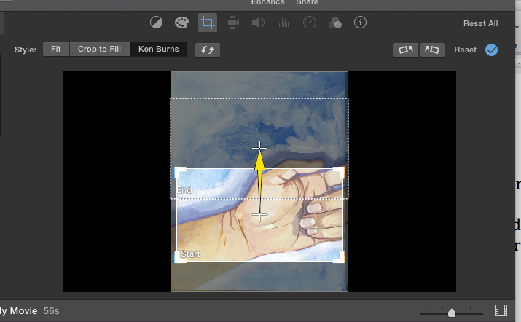
Import your pictures by dragging them into the iMovie window. Begin a new project (click on the NEW button on the top, name your movie, then click OK). Drag all of your photos to the bottom workspace, making sure you keep them in order.

Once they’re down below, choose all photos by dragging a box across them (or by choosing “edit>select all” or choosing ⌘ A), and in the top right hand corner, you will see a preview. Click on the crop tool, and another menu will come up. Choose “fit,” and this will remove the Ken Burns effect from all of your photos in the timeline.

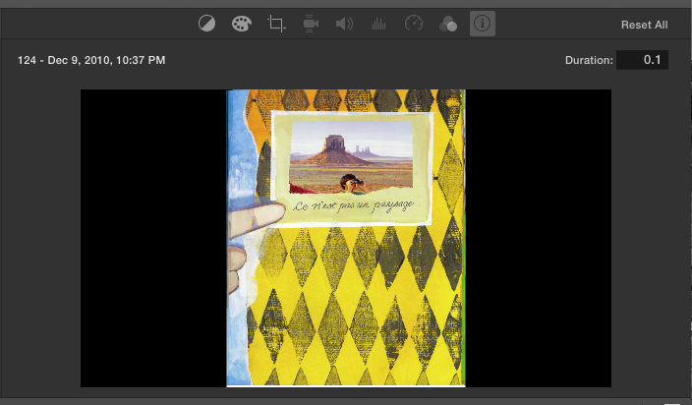

Next, click on the information logo (i in a circle), and you can shorten your clips. For 10 frames per second (the most typical we use), type in .1 in the duration box. This will shorten all your pictures so that your movie will run at 10 frames per second.

Once you get them all lined up, you can export your movie. Go to share>export movie. Choose medium size, and be sure you know where you’re exporting it to (I use the desktop).

To further edit your movie start a new project, and import your movie again. Now it will be one complete movie instead of a list of still images. You can clip your movie into individual segments by putting the slider exactly where you want to split the clip, then clicking on Modify>split clip or by using ⌘ B

When you’ve finished, you can add music by dragging your audio file onto your movie in the timeline, and making sure it lines up at the beginning. Finally, export your finished movie the same way and you’re finished!

