8bit Painter
*****Name****
****Date****

The app I will review is 8bit Painter by OneTap Japan, available only on the Google Play Store. Having an interest in creating pixel art, I searched for a mobile app on there and was interested based on its rating and reviews. It is free but contains ads in the workspace and sometimes unskippable ads when changing screens within the app. You can pay $3.99 to remove ads but I think it is a small annoyance and does not hinder the experience.
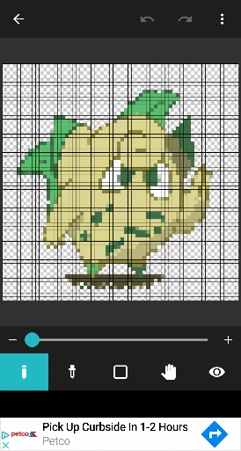
Like the name suggests, you can design art pieces using the grid on the workspace and its small selection of tools to create your art with the color palette. The tools are the Pencil (to draw,) Paint Bucket (to fill a space with a color,) Eyedropper (choose a specific color), and Eraser. It contains features to zoom, rotate, share to different platforms, and import images from your device.
Once you open the app, it shows you how to use and navigate in the app. If you go to the page on the Play Store, there are more images as well and tutorial video. Overall, it is pretty simple and straightforward to use. There are different dimensions in which you can create your art. The ads will keep popping out but the interface and response on the app will still work smoothly.
It is limited on what it can do and do not expect to create art bigger than 125 x 125 pixels. You will mainly use the pencil tool and I would prefer if there was an option to increase brush size and possibly create more other related tools to use. It has a feature to import images and I think it works best with high resolution images.
On the positive side, my experience with 8bit Painter was pleasant! While still limited, it does what it can exceptionally. Interface is simple and anyone can grab it and use on the first try. Below is some art I imported and then edited into the app

