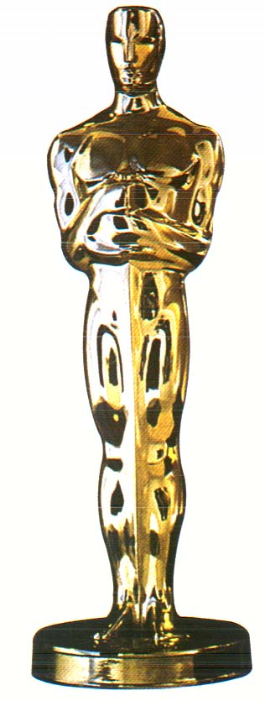

Best sound efects

Most Creative

Best drawing

Best story

Best special effects

Best soundtrack

Best claymation

Smoothest animation

Best claymation

Best special effects

Best soundtrack

Most Creative

Best sound efects

Smoothest animation

Best drawing

Best story

Best use of humor

Best use of humor

Best Picture

Best Picture

ART 305

Film Fest Awards

ART 305

Film Fest Awards