Game Maker Tutorial
Creating Sprites
Sprites are pictures, and we start by uploading the pictures of each object we’ll be using.

1. Click the Name field, where it currently says sprite0. Game Maker will always create default names but you should rename it to sprite_player
2. Click the Load Sprite button. This will open a file window. Find “Example Folder” or the folder that you put the example sprites.
3. Select the player image and click OK.
Did your sprite show up in the Sprite Folder? Good. Repeat the steps until you have these:
sprite_boss sprite_avoid
sprite_wall sprite_contact
sprite_release sprite_player
If you ever need to change a resource, you can reopen its properties by double clicking on its name in the resource folder

Create your Objects
Objects are items that have properties, and each one will use a sprite to represent in the game

Create a wall object:
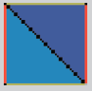
1. Click Create Object and change the name to object_wall.
2. Click the icon at the end of the sprite field. Select the sprite_wall to assign the image to the object.
3. Make sure ‘Visible’ and ‘Solid’ are both checked. If you later want the barriers to be invisible, you will simply deselect ‘Visible’. If the object isn’t solid, you would go through it.
4. Click OK to approve the changes.

Create the Player Object
1. Create an object , name it object_player, and choose the sprite_player.
2. Click Add Event and select Collision with object_wall.
3. Find Move Fixed in the Move tab and drag the icon to the actions space. In the popup window, click the center square and set the speed at 0. Click OK.
4. Click Add Event and select Keyboard . In the drop-down menu, select Left.
5. Find Jump to Position in the Move tab and drag the icon to the actions space.
6. In the pop-up menu, type -4 in x. Check Relative.
7. Make sure Applies to: Self is checked before clicking OK.
Let’s repeat step 4-7 for Right, Up, and Down using these settings:
Event: Keyboard <Right>
Action: Jump to Position
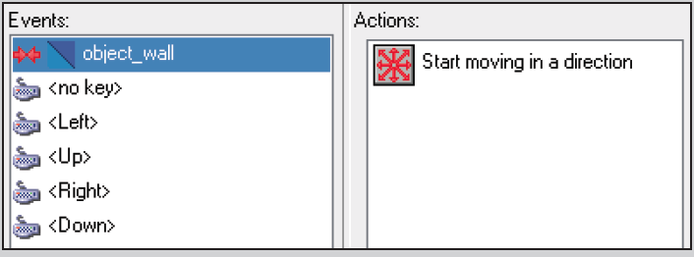
x: 4
Check relative
Event: Keyboard <Up>
Action: Jump to Position
y: -4
Check relative
Event: Keyboard <Down>
Action: Jump to Position
y: 4
Check relative Your finished player should look like this, then click “OK”

Making a room:
1. First make sure you there are no open sprite or object windows. Game Maker will not accept changes until you click OK. So if you have changes made in still-open windows, they won’t appear in your game!
2. Find and click the Create Room icon in the menu bar. Maximize the window so that you can see the entire room.
3. Click Settings. Name this room room_test in the name field. You will test objects for functionality in this room and can delete it after the game is complete.
4. Make sure the room is width=640, height=480 and snap X=32, snap Y=32. This will put a grid on the screen that helps object placement. The grid does not appear when you play the game.
5. Click the Objects tab. In the drop down menu, select your object_wall. Place a surrounding barrier inside the room with left click.
6. Now select object_player and click a place in the left side of the room, but make sure it doesn’t overlap an object_wall. If objects are partially outside the room, they may be paralyzed in game play.
7. When you are ready, click the green checkmark and find the Run the Game button in the menu bar.

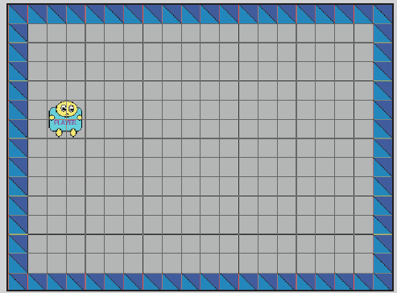
example room ready to go

