HOW TO MAKE AN AUDIO/VISUAL PRESENTATION ON CANVA
TUTORIAL: https://www.youtube.com/watch?v=HguHXjS1tNA

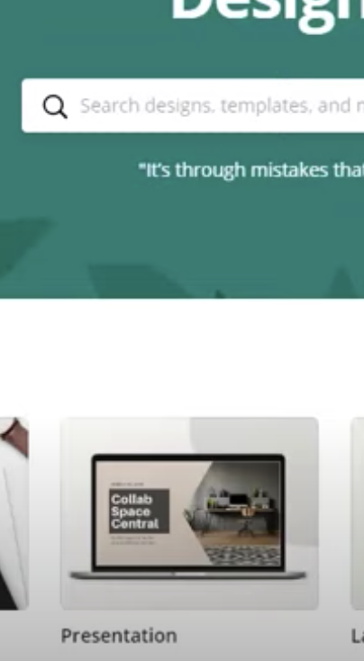
- Go to Canva: open a presentation application:
Choose icon OR
Type in search bar

- Upload your 30 images on the left hand side button
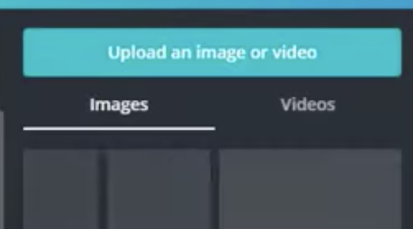

- Drag images to the slide on the right . To add slides click on the bottom “Add Slide” Button
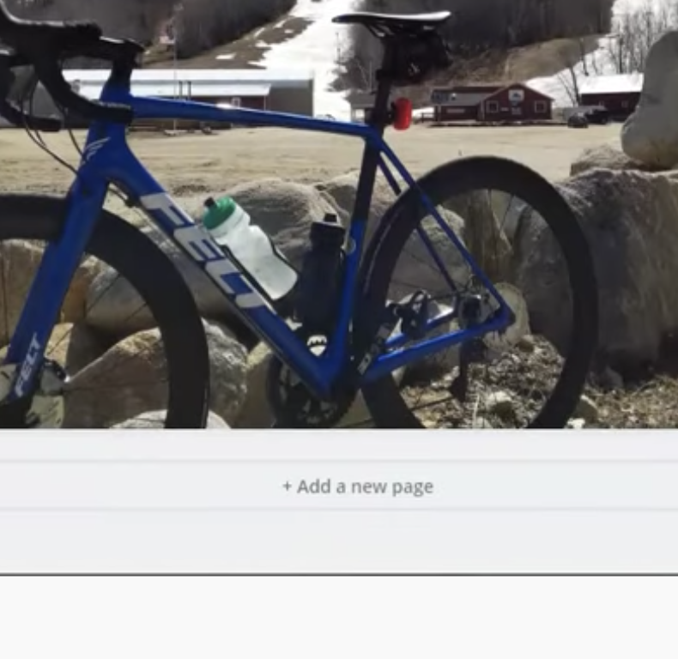

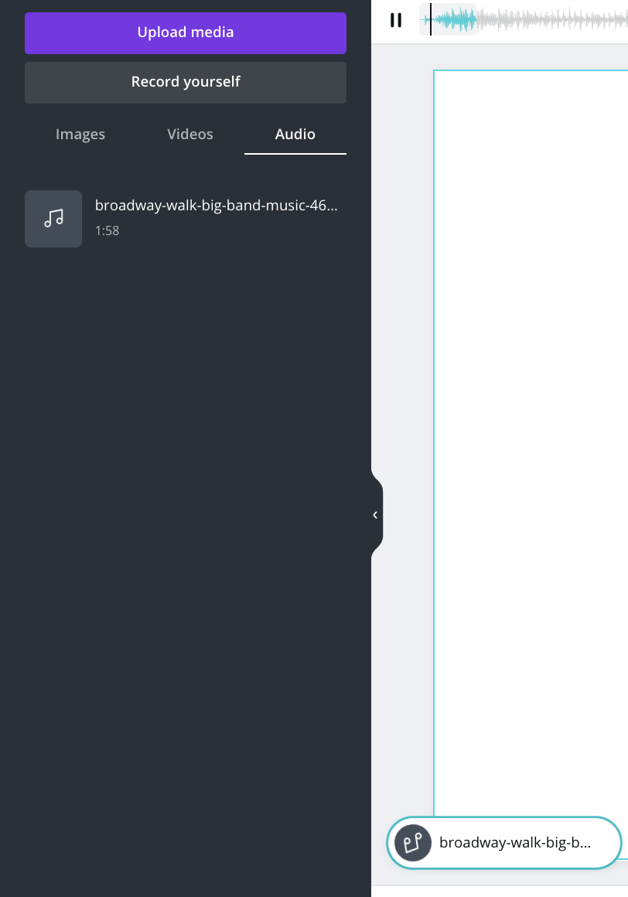
- To add audio: Audio MUST be an MP3/ Drag audio to the slide

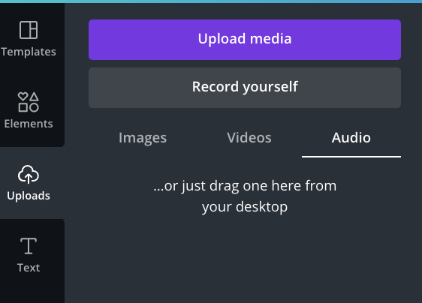

- Time each slide the length of time of the audio FOR EACH SLIDE by THE AUDIO SHOULD BE TAYLORED AND TIMED FOR EACH SLIDE:
- Clicking on the slide
- Click on the. Clock timer on top left hand side
- TYPE IN THE TIMING IN SECONDS FOR THE length of the audio FOR THAT PARTICULAR SLIDE
- Do this for all slides

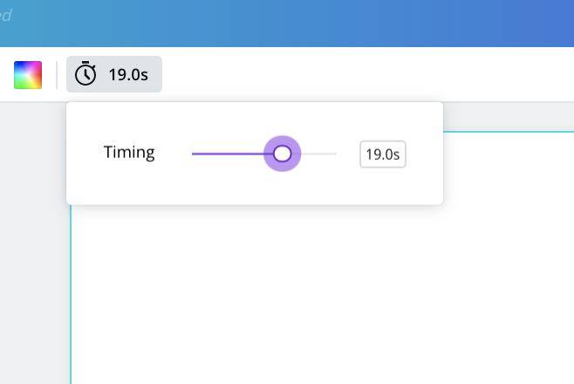

- TO PREVIEW THE VIDEO:
Go to the THREE DOTS ON TOP RIGHT HAND CORNER AND GO TO PRESENT TO PREVIEW

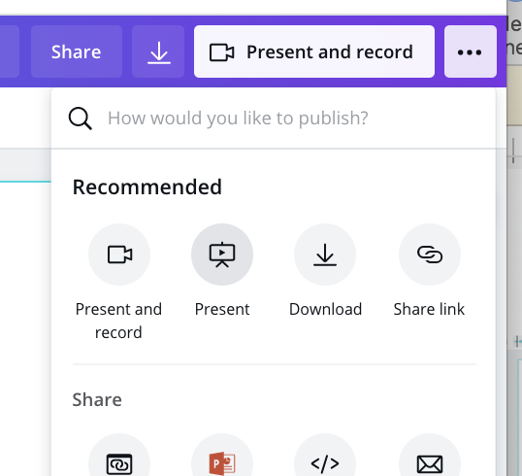

- TO SAVE VIDEO: SAVE AS MP4: GO TO THE DOWNLOAD ARROW, CHOOSE FILE TYOE MP4, CLICK ON DOWNLOAD.

